Nama : Afrizal Akbar

Nim : 171410173

Kelas : SI7K

Mid Mobile Technology

1. Tampilan Flutlab.io

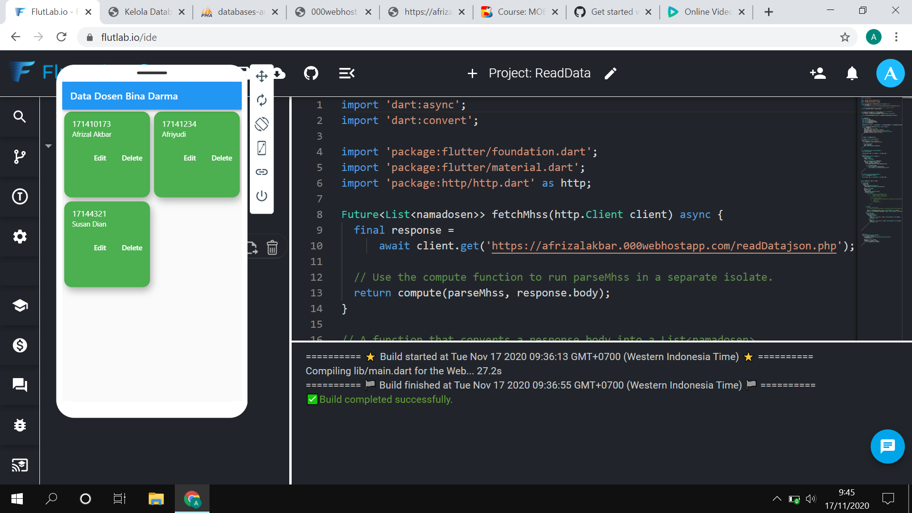

1. Tampilan Database

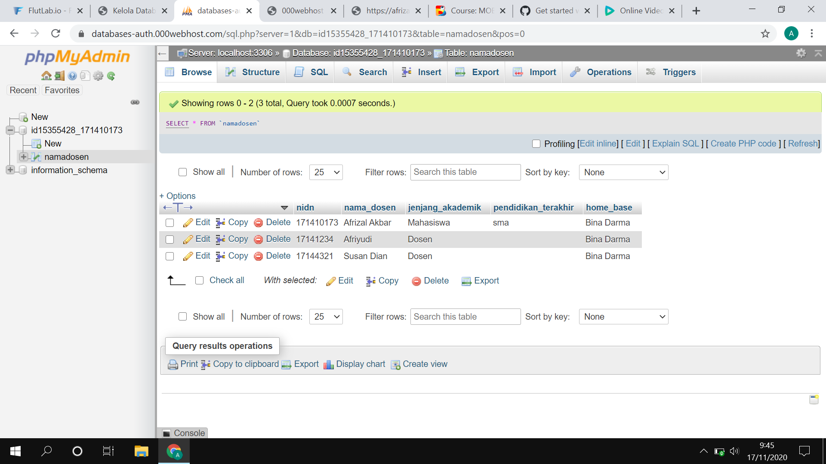

1. Compile & Running Video



1. Link Github: https://github.com/Afrizalakbar2218/testDB